
Dome and Shutter Control Manual
Meridian Controls Corporation
PO Box 839
1085 2nd Street
Berthoud, CO 80513-0839
Phone: 877-295-9797
Intl Phone: 970-532-1078
Fax: 530-325-7700
Email: ttm@meridiancontrols.com
Version: October 19, 2004
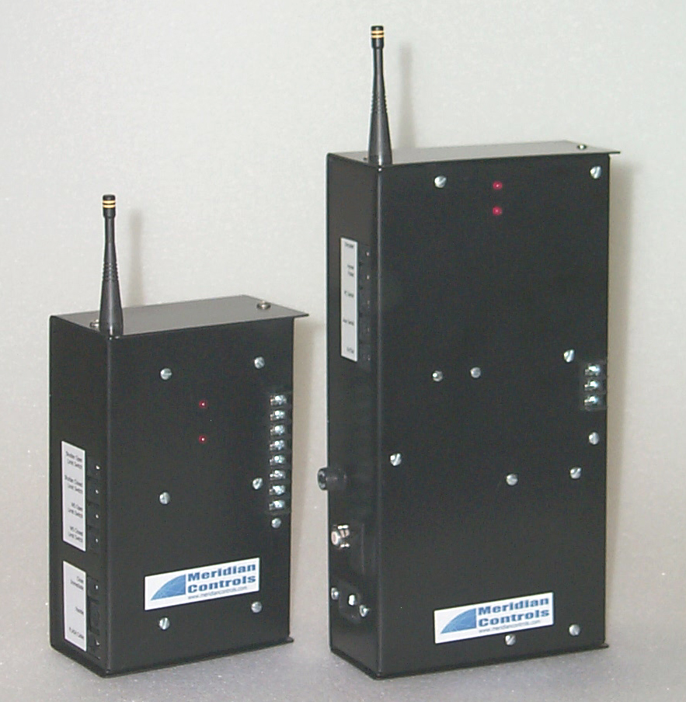
Table of Contents

Introduction 3
Basic Theory of Operation 4
Manual Operation 5
Installation of Dome Control Software 6
FLASH Software installation 7
MNCPTalk Software installation/setup 8
AutomaDome Software installation 10
Setting up TheSky for dome Control 12
Setting up the GEOMETRY section of AutomaDome 14
SAMPLE Startup Telescope and Dome 16
SAMPLE Shutdown Telescope and Dome 17
System Block Diagram 18
Connections and Wiring 19
Wiring Details 21
Wiring Details 22
ACL-DOME Commands (partial list) 23
Specifications 24

Introduction
This manual describes the Dome Automation System supplied by Meridian Controls Corporation. This system works with several types of domes. Throughout the manual you will see the reference (A), (B), (O);
- Represents the type shutter where the main (or primary) shutter lifts up and over the top of the dome and the lower shutter (or wind screen) is raised by a latching mechanism on the bottom of the main shutter. We call these types of domes “Latch and Pull-Up”. An example of this type of dome is the ASH Manufacturing REA.
- Represents the type of shutter where the main (or primary) shutter lifts up and over the top of the dome and the lower shutter (or wind screen), is hinged at the bottom and folds out to open. We call these types of domes “foldout lower shutter”. An example of this type of shutter is the ASH Manufacturing REB.
(O) Represents the type of shutter where the two-piece shutter splits vertically in the middle and moves horizontally to open. We call this type of shutter the “two piece, side to side”. An example of this type of dome is the unit built by Observa-DOME.

TheSky, AutomaDome, Orchestrate and IAS (Internet Astronomy Suite) are registered trade marks of Software Bisque, Golden CO

Basic Theory of Operation
Please see System Block Diagram. When you slew to an object in TheSky, AutomaDome grabs the azimuth where the telescope will be when it is pointing at that object. AutomaDome then corrects this azimuth position for several factors (location of the telescope in the dome and optical offsets). The corrected azimuth is sent to the Meridian Controls Corporation Dome Controller and the dome is rotated to this corrected azimuth. Several things need to be correct for all this to happen properly:
- The telescope needs to be properly set up or TheSky will not accurately know the object azimuth. Site and Time/Date are the keys here.
- AutomaDome must have proper information (Geometry Set Up) in order to make the needed corrections to the telescope azimuth.
- The dome must be properly initialized. During the set up of your dome control system, the home pulse sensor magnet was attached to your dome so that it is opposite the home pulse sensor when the dome is parked. The azimuth of the sensor was entered into the permanent memory of the Dome Controller when the procedure “home setup” was done using MNCPtalk. When you start your system, you do a “home find’. This initialization sets the dome azimuth when the dome is rotated and the home sensor magnet is found.
If the installer set up your dome control system, then this manual becomes a reference document only. If your dome is not following the telescope motion at all, then perform the steps listed in the Installation of Dome Control Software section of this manual. If the dome is following the telescope, but the shutter opening is always off center in one direction and by the same amount, then perform the steps listed in MNCPTalk Software Installation/Setup. If the dome is following the telescope, but the shutter opening is off center by different amounts and in different directions, then perform the steps listed in Setting up the Geometry section of AutomaDome.

Manual Operation

Push Buttons Function

Left/ Right: Rotates Dome in azimuth

Open Opens the Shutter

Close Closes Shutter/Wind Screen

Wind Screen Open/Closes Windscreen (A), (B)

Stop Stops Dome Rotation/Shutter Motion

Both the Dome Controller and Shutter Controllers have power switches. Press the upper portion to turn it on.

The Dome Controller has two red LED indicators. The top LED indicates the power is on and the controller is operating. The lower is spare and for future use.

The Shutter Controller has two red LED indicators. The top LED indicates the power is on and the Controller is operating. The lower LED indicates the battery is being charged from the solar panel.

The Dome Controller has a (smaller domes) five (5) amp or (larger domes) ten (10) amp circuit breaker for protection of the dome rotation motor(s). Press to reset. A one (1) amp slow blow fuse protects the logic circuits.

The Shutter Controller has two circuit breakers. The value depends on the size of motor(s) used in your system. The larger value breaker protects the main shutter motor (A), (B), (O). The smaller value breaker protects the windscreen motor (A), (B).

Both controllers have several phone type jacks for connection of the various limit switches, serial connections, weather station, etc. Each of these connectors has a label describing it’s function.

Installation of Dome Control Software

Needed:
1. FLASH serial cable for connection between the PC and the Dome controller.
2. FLASH download software (Remote Field Utility-RFU). Use this software to download the new software into the dome and shutter controllers.
- AutomaDome (Software Bisque) software on CD ROM.
- MNCPTalk (Meridian Controls Corporation) on CD ROM. This software is needed for the setup of your dome control system.
5. This (and possibly other) documents.

Remember, you will only need to do this procedure once!

Procedure: Please do this in the sequence shown.
1. Download (FLASH) new software into the Dome and Shutter Controllers only if the latest software is of a higher revision number than the software currently installed.
2. Verify (using MNCPTalk) that the dome system is communicating with the PC.
3. Using MNCPTalk, set home/park position and other constants.
4. Using AutomaDome, verify proper dome/TheSky operation.
5. Setup TheSky for use with AutomaDome
6. Test and verify operation of coupled Telescope and dome.
7. Setup and test the Geometry section of AutomaDome.

FLASH Software installation
The system was designed with all of these type shutters in mind. Software implications of these types of shutters are significant as the sequence of operation is different and the numbers of motors vary. Please note that there is NO difference in the software running in the Dome Controller with the different types of shutters. All are treated the same. THERE IS HOWEVER a difference in the software running in the Shutter Controller. When downloading the FLASH memory of the controllers, you MUST BE CAREFUL of what source file you select. Files destined for downloading into the Dome and Shutter Controllers will have the form:
DOME-Vxxx.BIN where xxx is the version (example DOME-V101.BIN)
SHUT-A-Vxxx.BIN where xxx is the version (example SHUT-A-V101.BIN and this is a type A shutter
- If this software was supplied to you on CD ROM, you must move the files to your hard drive.
- You must run the application from your hard drive, we suggest that you install all the files into a directory named “Meridian” and if possible (but not required) under the root directory.
3. Turn the power off to the Dome controller. Plug the FLASH cable supplied (do not use the cable marked PCSER) with the dome control system into the dome controller connector marked “FLASH” and the DB-9 connector into COM1 serial port of your computer (we suggest that the computer be off when you plug the cable in).
4. Turn power on to the Dome Controller.
5. Navigate to the file RFU.EXE on your hard drive and launch it (double click on it).
6. Click on SETUP, then COMMUNICATIONS and verify that the proper serial port is in use.
7. Click on OK to go back one level and click on BOOT STRAP LOADERS, then click on the button COLD LOADERS and set the window (button to the right of the window) to use COLDLOAD.BIN. Do the same for the PILOT.BIN. Make sure the path points to these files on your hard drive. Click OK to go back one level.
8. Click on FILE and LOAD FLASH IMAGE, navigate (as above) to DOME-VXXX.bin.
9. Click the OK button. If all has gone well, you will see the status of the download. Downloading will take less than a minute.
10. Close the RFU. Turn off the power to the Dome Controller. Disconnect the Flash cable from, and turn on the power to the Dome Controller. You should see the top indicator LED come on.
11. Now do the exact same procedure to the Shutter controller using the same FLASH cable but this time download the file SHUT-VXXX.BIN, and put the FLASH cable away for safe keeping.

MNCPTalk Software installation/setup

- This software assumes that the dome controller be connected to serial port COM1. Use the cable marked DOME PCSER, DO NOT USE THE FLASH CABLE. Turn off the power to your PC and the Dome controller. Plug the DB-9 connector (marked DOME PCSER) into COM1 serial port of your computer. If you have something attached to COM1 now, temporarily remove that device. Once your dome has been set up using MNCPTalk, you may reconnect the device that was originally connected to this COM! Port (if any).
- This software may be run directly from the CD ROM, or you may move the files to your hard drive.
3. If you load this software onto your hard drive, I suggest that you install it in a directory named “Meridian” and if possible (but not required) under the root directory.
4. Startup your PC, Shutter and Dome controllers. When the PC is ready, navigate to the file mncptalk.exe and launch it (double click on it).
5. If all goes well, you will see:
Connecting to unit 1 . . .
1>
6. If not, recheck all connections and make sure serial cable is connected to COM1.
7. All commands in MNCPTalk are lower case. Type device (lowercase) and press enter. You will see:
Meridian Controls Corporation Dome Controller X.XX
1>
The numbers at the far right hand side of the display indicate the current software revision installed
8. Now try a few basic commands:
move west (and then the ENTER key) This will cause the dome to move to the right.
stop west this will stop the dome rotation.
move east dome moves left.
stop east will stop the dome rotation.
Make sure it is OK to open the dome, then type;
open the main shutter will begin to open.
stop will stop the dome opening.
close will close anything that is open

9. After you have had some fun, let’s get back to work, lists of basic commands (like the ones above) are listed elsewhere.
10. Place the home sensor magnet (attached to the dome) about 1 foot to the left of the home sensor reed switch using the LEFT and RIGHT buttons. Type the following command:
x_findcounts the dome will make one complete revolution to the right and stops. This determine the size of the dome.
11. Place the center of the shutter opening to true North using the LEFT and RIGHT buttons. Type the command:
set az = 0.0d nothing obvious will happen.

Type the command:
get az you will see:
az = 000d00m00s
1>
12. Place the home sensor magnet (attached to the dome) about 1 foot to the left of the home sensor magnet reed switch using the LEFT and RIGHT buttons. Type the following command:
home setup the dome will move to the right and stop after sensing the magnet. This sets the azimuth angle associated with the home pulse sensor.
13. Place the home sensor magnet (attached to the dome) about 1 foot to the left of the home sensor magnet reed switch using the LEFT and RIGHT buttons. Type the following command:
home find the dome will move to the right and stop after sensing the magnet. Home find is a command you will use every time you start up the system. From now on you will not need to use MNCPTalk, as the normal functions are incorporated within AutomaDome.
14. Take a break, get a cold soda and we will have some more fun!

AutomaDome Software installation
- AutomaDome is supplied by Software Bisque on CD ROM. Insert the CD ROM into a CD drive. On this CD ROM there is a text file with the needed password to install the software. If the CD ROM does not automatically start the installer, navigate to the file on the CD ROM and launch (double click) on the file. Follow the instructions (not many) and install AutomaDome. We strongly suggest that you install all of Software Bisque products in the default file structure. This makes phone support much easier for you and the supplier.
- With MS Notepad, make the following file and store it in C:\windows\MERLINDOME.INI:
[MERLINDOME]
OpenTimeout=1000
CloseTimeout=1000

- You MUST ALSO HAVE Orchestrate and a file named OB.EXE installed on you computer for the full system to work. Orchestrate and OB.EXE are part of the Software Bisque IAS (Internet Astronomy Suite). If you do not have these two files, call Meridian Controls Corporation and we will see that you get them. You will need to launch these two applications at least once so that these programs are installed in your computer. If you have Windows 98, you will probably be asked to re-boot. Do this!
- Connect the DB-9 end of the serial cable marked PCSER to a working, unused, serial port on your computer. Plug the other end of this cable into the Dome Controller into the receptacle marked PCSER.
- Launch (double click) on the AutomaDome icon, or if the icon was not installed on your desk top, navigate to AUTOMADOME.EXE and double click on it. This file is usually installed at c:\program files\software bisque\automadome. You may want to create a “shortcut” and place it on the desktop.
- Familiarize yourself with this software, this will be the primary tool for controlling the dome.
- Click on DOME and SETUP. Set the serial COM port to the serial port you are using. Leave the BAUD RATE set to 9600. Set the ACL ADDRESS to 1. Later you will learn about the GEOMETRY and SECURITY sections of AutomaDome. Click OK
- Click DOME/LINK/ESTABLISH. When the connection is made, the value next to the word Azimuth: will show the current position of the dome.
- Click on DOME and you will several options, these are the main ones you will use:
LINK ESTABLISH as above.

OPEN SLIT opens the shutter.

CLOSE SLIT closes the shutter.

FIND HOME initializes the dome, must be done at the beginning of every session.

PARK sends the dome to the park position, must be done at the end of every session so that the solar panel will charge the battery properly.

- Do not use the SYNC command until you are absolutely sure what it does! This can create temporary dome pointing errors. If the dome is not pointing properly, then you need to fix the initial HOME POSITION setting and/or the DOME GEOMETRY.

Setting up TheSky for dome Control
- If you have Windows NT, 2000 or XP you will need to fix a problem with the Windows Path. You may find the procedure for this on the Software Bisque web page (www.bisque.com). We have copied this information below for your convenience:
  - Click Start | Settings | Control Panel and then double click the System icon.
  - In the System Properties window, click the Environment Tab.
  - Click the Path variable in the System Variables List.
  - In the Variable text box, add a semi-colon (;) to the end of the existing path and then add the text “C:\Proram Files \ Common Files \ System” without the quotes.
  - Click the Set button. If you do not click the Set button, the path will not be set!
  - Click OK.
Restart your computer for these new settings to take effect.
2. Update your version of The Sky from the Software Bisque web site often. If you have not done it within the last couple months, do it now.
3. Did you run Orchestrate at least once as mentioned previously? If not, do so now.
4. Navigate to the application OB.EXE and launch it. It may usually be found in C:\Program Files\Software Bisque\Orchestrate. No need to create a shortcut for this application, you will not use it very often. In OB.EXE, click on OBSERVATORY and SERVER CONNECTIONS. Make sure that AutomaDome has a check mark by it, if not, click on the box to the left of AutomaDome. Click OK and close OB.EXE.
5. Launch TheSky, start up you telescope normally, verify that TheSky and your telescope are working normally. Slew your telescope to an object that TheSky says is due South and about 20 degrees above the horizon (you can use grid lines). The object information should indicate that the object has an azimuth of something close to 180 degrees. If not, select another object until you see an object azimuth of 180 degrees + or – 5 degrees. Now look at the telescope, is it fact pointing to true South? If it is not, you need to solve this problem now before going on with the set up of the dome control. Usually this problem is caused by incorrect site or time settings within TheSky. You may not know that you have this problem because the telescope is finding objects just fine, but the where and/or when of the system is incorrect.
6. With TheSky window active (the bar along the top of the window is blue, not gray), press the following three keys at the same time CTRL SHIFT D (the control, shift bar and the letter D). $25 to the first person who can find this keystroke sequence in the Software Bisque documentation! A new window will appear; it looks like AutomaDome but is not, it is the DOME CONTROLLER. In the DOME CONTROLLER, click on DOME, SETUP and put a checkmark in the box marked Local Connection. Now click on OK. Close the DOME CONTROLLER window, Park and shutdown your telescope, close TheSky and answer the question “SAVE CHANGES TO NORMAL SKY” yes.
7. Now launch AutomaDome. Click DOME/LINK/ESTABLISH.
8. Launch TheSky.
9. Launch DOME CONTROLLER (CTRL/SHIFT/D) while TheSky window is active. Click DOME/LINK/ESTABLISH. If you get a serial timeout error, check to make sure that the power to the Dome Controller is on, and the serial cable is connected properly. If you get a different error, this is probably due to not having set the Window path set as shown above (NT, 2000 and XP users). When successful, a representation of the dome shutter will appear on TheSky display. At times this 4-sided shape can look a bit strange, but this is due to the type of projection used by TheSky.
10. Place a check mark next to the item COUPLED.
11. Start up you telescope normally.
12. When you slew the telescope to an object the dome will now follow. Don’t be concerned that the shutter opening is not always centered in front of the telescope, the GEOMETRY section of AutomaDome will fix this.

Enclosed in this manual is a suggested startup and shutdown procedure. It is strongly suggested that you create a version of this that is appropriate for your observatory and its users. Have this checklist laminated and permanently attached on or near the telescope/dome computer.

Setting up the GEOMETRY section of AutomaDome

AutomaDome’s primary function is to correct for mechanical and optical issues with the telescope and telescope mount. The biggest issue occurs when you have a German Equatorial telescope mount. When the telescope is pointing on the East side of the meridian, the optical path is way off center to the WEST and the opposite is true for the West side of the meridian. Other issues fixed by AutomaDome include problems with the mount not being in the center of the dome or at the proper height in the dome.

We suggest you use inches as your primary unit of measurement and rounding to the nearest inch should be OK. Most (if not all) measurements are made from the intersection of the RA and DEC axis (RAxDEC hereafter). On a fork mount, this point would be inside the optical tube where the polar axel and the DEC shafts would meet. It is easier to find this point on a German Equatorial mount because this intersection is out in the open.

Getting this “just right” can be a little frustrating at times. The constants that you need to enter are not intuitive, but a little time spent here will yield excellent dome pointing. The key to AutomaDome GEOMETRY is setting up the location of the mount in the dome and where the optical path is in relation to the mount. A lengthy description of AutomaDome can be found at http://www.bisque.com/Products/AutomaDome/automadome.asp. Launch AutomaDome, then click Dome, Setup and Geometry. The values are as follows:

Phi (equatorial mount) site Latitude in radians (2 * pi radians = 360 degrees)
Examples: site Latitude is 40 degrees North (40/360) * (3.1416 * 2) = .70
site Latitude is 34 degrees North (34/360) * (3.1416 * 2) = .59

Dome radius is the diameter of your dome/2
Example: Your dome is 14’-6” in diameter Dome Radius is 87

Xm is the East/West offset of RAxDEC from the center of the dome
Examples: Scope RAxDEC is 6 inches East of the center of the dome Xm = +6
Scope RAxDEC is 4 inches West of the center of the dome Xm = -4

Ym is the North/South offset of RAxDEC from the center of the dome
Examples: Scope RAxDEC is 4 inches North of the center of the dome, Ym = +4
Scope RAxDEC is 7 inches South of the center of the dome, Ym = -7

Zm is the Up/Down offset of RAxDEC from the center of curvature of the dome
Examples: Scope RAxDEC is 2 inches above the center of the dome, Zm = +2
Scope RAxDEC is 9 inches below the center of the dome, Zm = - 9

Xt is the offset of the optical center from RAxDEC
Example: If your optical center is 17 inches from RAxDEC (as in a German Equatorial Mount) then Xt = 17 (note: for some unknown reason, you must put a minus sign in front of this value for proper operation, as in –17)
If you have a fork mount, Xt is likely to be zero
Yt = 0

Offset of optical axis from the telescope = 0

Once you have these settings made and debugged, write them down so you will not have to endure the pain of figuring them out again!

SAMPLE Startup Telescope and Dome

Power on Telescope and Dome:
- Turn power on located on the silver panel at the top of the stairs. (Black switch on left)
- Open dome slit (press the WS button on the gray controller box located on the dome)

PC Time:
- Open the Set PC Time application
- Enter the current time from the dark gray clock or by calling a time service using a phone. Be sure to enter the time in 24 hour mode along with the seconds. Example: 9:35 p.m. is 21:35:00
- Close the Set PC Time application

Set Sidereal time in Telescope:
- Open the MCCScope application; press OK
- Establish a connection with the telescope (Communications/Establish)
- Set sidereal using the PC clock (Menu). (Set/Sidereal Time/Use PC Clock)
- Terminate connection with telescope (Communications/Break
- Close the MCCScope application

Start Software Applications:
- Open the IASServer (Internet Astronomy Suite) application
- Start the applications. (Start Applications Button)
- Minimize the IASServer application

Startup Dome:
- Establish a connection to the dome using AutomaDome. (Dome/Link/Establish)
- Minimize the AutomaDome application
- Minimize the CCDSoft Application
- Open “Dome Controller” window in TheSky application. Be sure that TheSky application is selected;
then press Ctrl-Shift-D.
- Establish a link between TheSky and AutomaDome using Dome Controller. (Dome/Link/Establish)
- Make sure the dome is near the Park location. (The ??? Pointers on the dome should be aligned. If not use the two buttons on the gray box below the silver power panel to align the dome pointers.
- Issue a Find Home command to the dome using Dome Controller (Dome/Find Home)
- Minimize or close the Dome Controller window

Startup Telescope
- Establish a connection between the telescope and TheSky application (Telescope/Link/Establish)
- Make sure the scope is in the Park location (Both sets of orange pointers on the scope should be aligned. If not use the hand paddle to align both sets.
- Issue a Find Home command to the telescope (Telescope/Options/Find Home)
- Wait for the Find Home command to complete
- Use the hand paddle or slew the scope to a low reachable position and remove the dust cover from the scope
- The system is now ready for use

SAMPLE Shutdown Telescope and Dome

Shutdown Telescope:
- Use the hand paddle or slew the scope to a low reachable position and replace the dust cover on the scope,
- Issue a Park command to the telescope in TheSky application (Telescope/Options/Park)
- Wait for command to complete (Two sets of beeps)

Shutdown Dome:
- Close the dome slit. (This operations can be done at any time, even before operation1 of Shutdown Telescope. (Press the Close button on the black controller box located on the dome.
- Reopen the Dome Controller window in TheSky (Maximize or press Ctrl-Shift-D again if the window is closed.
- Issue a Park command to the dome using Dome Controller. (Dome/Park)
- Wait for the Park command to complete before doing next operation.
- Disconnect dome link between TheSky and AutomaDome using Dome Controller (Dome/Link/Terminate)
- Maximize the AutomaDome application
- Disconnect AutomaDome from the dome. (Do not close AutomaDome application) (Dome/Link/Terminate)

Shutdown Applications:
- Maximize the IASServer application
- Shutdown the applications. (Exit Applications button)
- Close the IASServer application
- If any dialog boxes are open, answer their questions. Usually TheSky application is asking if you want to save changes to the Normal.Sky file. (Press Yes)

Power off Telescope and Dome:
- Turn off power located on the silver panel at the top of the stairs. (Black switch on left)
- You are now finished shutting down the system.

Note:
The above sample for an ACL compatible telescope using Software Bisque products. Your startup/shutdown procedure will be different. Use this example as a starting point for your checklist.

System Block Diagram
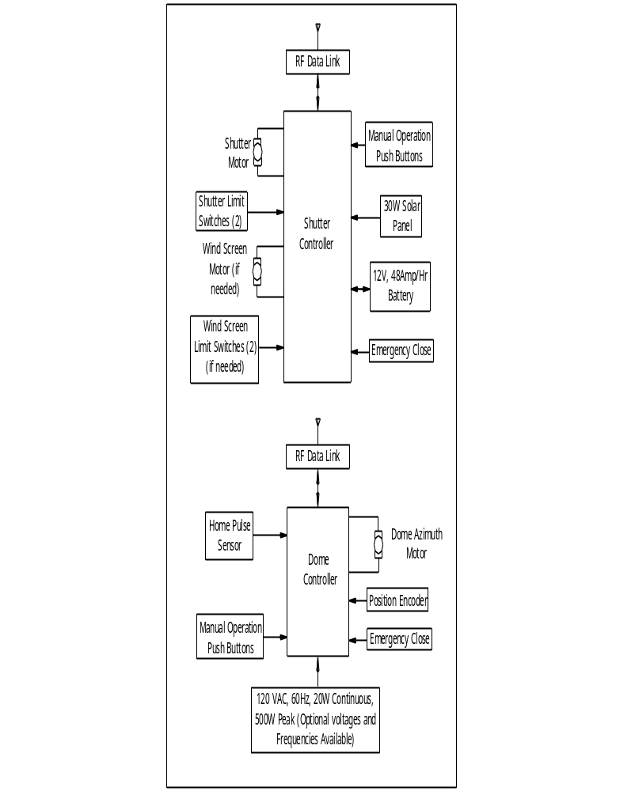

Connections and Wiring
Shutter Controller
Shutter 8 position Terminal Block
BATT+ Positive, +, Red Wire to Battery. For 1/3 and ½ HP shutter motors, this must be 10 GA wire. 14 GA wire OK for other motor sizes.
BATT- Negative, -, Black Wire to Battery. Wire size as above.
SMTR+ Positive, +, Red Wire to Shutter Motor. For 1/3 and ½ HP shutter motors, this must be 10 GA wire. 14 GA wire OK for other motor sizes.
SMTR-- Negative, -, Black Wire to Shutter Motor. Wire size as above.
WMTR+ Positive, +, Red Wire to Wind Screen Motor. 14-16 GA wire .
WMTR-- Negative, -, Black Wire to Shutter Motor. Wire size as above.
SLRP+ Positive, +, Red Wire to Solar Panel. 14-16 GA wire. Exterior wire must be weather resistant type.
SLRP- Negative, -, Black Wire to Solar Panel. 14-16 GA wire. Exterior wire must be weather resistant type.

Limit Switch Connectors
Shutter Open Connects to primary shutter open limit switch see notes 1, 2.
Limit Switch
Shutter Closed Connects to primary shutter closed limit switch, see notes 1,2.
Limit Switch
WS Open Connects to Wind Screen open limit switch, see notes 1,2.
Limit Switch
WS Closed Connects to Wind Screen open limit switch, see notes 1,2.
Limit Switch
Close Immediate Connects to Weather station or user supplied equipment, see note 1.
Details of this connector available upon request.

Paddle Connector Connects to 3 (O) or 4 (A,B) button control paddle. See note 2, 3.
Flash Cable This special cable allows for downloading new system software into the Shutter Controller from a PC. Not a general purpose serial cable.

Dome Controller
Three Position Terminal Block
AMTR+ Azimuth Motor +, Positive, Red wire to Azimuth motor. 16 GA shielded cable such as Digikey PN C2543-1000-ND).
AMTR- Azimuth Motor -, Negative, Black wire to Azimuth motor. Wire as above.
MTR GND Azimuth Motor ground (shield) wire.

Close Immediate Connects to Weather station or user supplied equipment, see note 1.
Details of this connector available upon request.

Paddle Connector Connects to 5 (O) or 6 (A,B) button control paddle. See note 2, 3.

Flash Cable This special cable allows for downloading new system software into the Dome Controller from a PC. Not a general purpose serial cable.

Close Immediate Connects to Weather station or user supplied equipment, see note 1, 2. Details of this connector available upon request.

Encoder Connects to position encoder (attached to azimuth motor (A, B) or friction driven encoder (O). See notes 1, 2.

Home Connects to Home Pulse sensor (magnetic reed switch, magnet on
Pulse dome, reed switch on or near, azimuth motor). See notes 1, 2.

PC Serial Connects to the system controlling PC. Meridian Controls Corporation supplies a standard 25’ cable , special lengths available. Cable diagram available on request.

Aux Serial Future use serial connection.

In/Out Future use parallel connection.

Note 1:
All limit switch cables are 4 conductor, flat, telephone wire (Digikey PN H0042-X-ND). Use the narrow, handset, type plug (AMP PN 5-641334-3, Digikey PN A9091-ND).

Note 2:
Unlike telephone cables, all limit switch, encoder, home pulse, paddle and close immediate cables used in Meridian Controls Corporation products are built without a twist, in other words pin 1 to pin 1, pin 2 to pin 2, etc.

Note 3.
Use 8 conductor, flat, telephone wire (AMP PN XXXXX, Digikey PN XXXX) wire. Use 8 Position Plug (AMP 5-554739-3, Digikey PN A9094-ND).

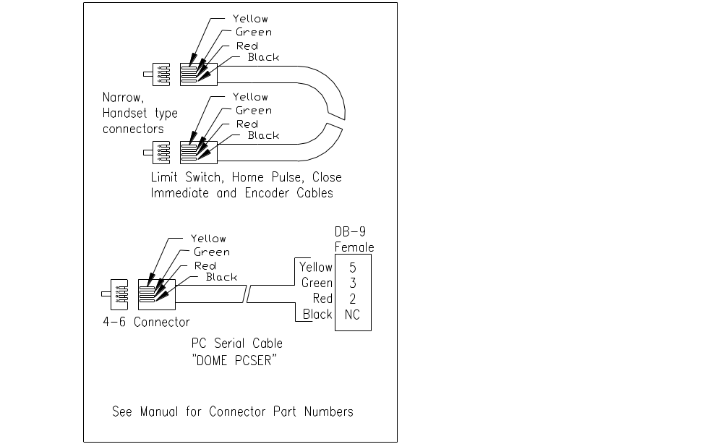Wiring Details

Wiring Details
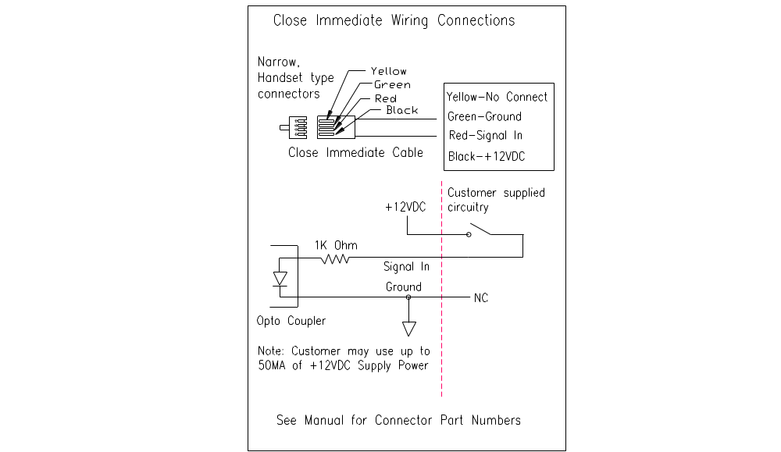

ACL-DOME Commands (partial list)
open open both upper and lower portions of dome
close close whatever is open
home find sends dome to home in az
home park sends dome to it’s park position
status returns 16 bit status word (see below)
sync forces dome az=telescopeaz
stop (east, west) stops motion in the specific direction
move (east, west) move at current speed
telescopeaz the azimuth of the telescope (used in goto)
goto sends dome az to desired telescope az
home setup* sets dome controller azimuth home sensor location
x_findcounts* determines dome size in encoder counts
status word:
bit 0 Reserved
bit 1 goto in progress if 1 [read only]
bit 2 home in progress if 1 [read only]
bit 3 Last home search failed if 1 [read only]
bits 4 to 15 Reserved

typical start-up of dome:
home find wait for status bit 2 to go to a logical 1 then 0
open opens dome shutter (windscreen)

typical operation
set telescopeaz=164.8d set desired shutter azimuth
goto send dome to desired azimuth
set telescopeaz=124.2d set desired shutter azimuth
goto send dome to desired azimuth
.
.

typical shut-down
close closes dome slit (windscreen)
home park send dome to park position

*=not part of normal operation, for initial set-up only

Some commands are read/write (like telescopeaz, you read it by “get” and write it with “set” see example above. Other commands (like “status”) are read only. For a full ACL document, send email request.

Specifications

- Closed-loop DC servo azimuth drive
- 900 MHz wireless encoded data link for automated dome remote control
- Computer controlled dome operation with RS-232 and manual control
- Power conditioning circuitry built-in for lightning strike and surge protection
- Dome initializing time estimated to be less than 2 minutes
- Dome opening/closing time estimated to be less than minutes.
- Shutter power from 30 watt solar panel charging 12 VDC, 48 amp hour gel cell battery
- Shutter battery sized to allow > 50 dome open/close cycles without charging
- Dome Controller power < 20 watts (no azimuth motion) ~ 500 watts while moving in azimuth
- System is 100% compliant to ACL-Dome (Astronomical Command Language) and is compatible with NASA/JPL/Telescopes In Education (TIE) networked telescopes
- Numerous fail –safe timers close dome should host communications be lost.
- Controllers utilize “Watch-Dog” timers and will automatically re-boot if a fault occurs.

